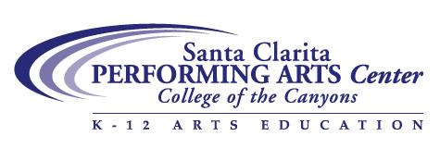
Peter Kors
Focus on Theatre
In-school Residency

Peter Kors brings a wealth of professional experience in theatre, music and performing arts education into the classroom. He has performed with the innovative children’s theatre group We Tell Stories and was featured in a number of productions with the Mark Taper Forum’s P.L.A.Y (Performing for Los Angeles Youth). Peter often works as a theatre arts teaching artist, both in the classroom and as a professional development presenter. Peter is a cofounder of the internationally acclaimed Dell’Arte School of Physical Theatre in Northern California, and teaches an acting class to high school students every summer.

Peter is a popular actor and storyteller with audiences throughout Los Angeles. He has been featured in films, on television—guest starring on “The West Wing” (NBC) and co-starring on “Bram and Alice,” (CBS) — as well as in interactive media, and as a voice actor in numerous films, commercials and television shows. He has performed on stage in cities from Seattle to San Francisco to San Diego, including the Mark Taper Forum Main Stage in Los Angeles.
Peter studied Music and Theatre Arts at San Francisco State University and became a protege of the internationally acclaimed Commedia Dell' Arte teacher, Carlo Mazzone-Clementi. His two biggest professional learning experiences were when he was the featured Comic Mime performing with Leontyne Price at the San Francisco Opera, and--his favorite "gig" - when, as a very young member of a youth chorus way back in the 60s, he performed and recorded with Duke Ellington and his Orchestra.

Workshop Description
Using theatre techniques, improvisation, storytelling and stage movement exercises, these workshops lead to a culminating performance of a scripted play. Participants learn how theatre can foster teamwork, strengthen self-confidence, improve self-image, and develop a creative approach to problem-solving.

Benefits of the program include enhanced literacy and oral language skills, increases in self-confidence and an increased appreciation for the performing arts. A program for young ESL students incorporates visuals, songs and simple role-playing to build English language development.

